SPRINT EXECUTION COMPLETION REPORT
Real-Time Customer Support Ticket CRM using Apache Kafka
Node.js · Express.js · MongoDB · JWT · bcrypt · Apache Kafka (KafkaJS)

Developer: Arpita Maleth | Reg No: CU23BCA0011A
Chanakya University | BCA Programme
Sprint 1 | Duration: 01 March 2026 – 14 March 2026 | Report Date: March 2026

1. Project Overview
The Real-Time Customer Support Ticket CRM is a full-stack web application designed to streamline customer support operations. Customers can raise support tickets, and agents can view, manage, and resolve them in real time. The system leverages Apache Kafka for event-driven communication between services, ensuring that ticket updates are propagated instantly across the platform.

The project is being developed using a solo agile approach across multiple sprints. Sprint 1 focuses on establishing the foundational infrastructure: the backend server, database connectivity, secure authentication, and a basic frontend UI.

Project Type: Solo Academic Project — Full-Stack Web Application
Tech Stack: Node.js, Express.js, MongoDB (Mongoose), JWT, bcrypt, KafkaJS, HTML/CSS/JS
Repository: CRM_BCA_project (local — VS Code, Windows PowerShell)

2. Sprint Goal & KPI Dashboard
The goal of Sprint 1 was to establish the core architecture of the CRM system — covering backend server setup, MongoDB database integration, secure user authentication (registration and login), and a basic frontend UI. All 5 user stories were completed within the 2-week sprint with zero carry-overs.

Total Sprints | Story Points Planned | Story Points Completed | Overall Status
1 (2-week cycle) | 30 pts | 30 pts (100%) | COMPLETE ✔

User Stories Delivered | Sprint Duration | Sprint Status | Bugs Resolved
5 / 5 | 01 Mar – 14 Mar 2026 | COMPLETE ✔ | 2 / 2 (Zero open)

3. Product Backlog (Sprint 1 Scope)
The following table lists all user stories scoped for Sprint 1, along with their priority, story point estimates, and completion status.

Story ID | Category | User Story / Task | Points | Priority | Status
US-001 | Backend Setup | Set up Node.js & Express server with routing structure for auth APIs | 6 | High | ✔ Done
US-002 | Database | Configure MongoDB with Mongoose and design User schema with role fields | 6 | High | ✔ Done
US-003 | Authentication | Implement Registration endpoint with bcrypt password hashing | 6 | High | ✔ Done
US-004 | Authentication | Implement Login endpoint with JWT token issuance and authMiddleware | 6 | High | ✔ Done
US-005 | Frontend | Build Login & Registration HTML/CSS pages connected to backend via Fetch | 6 | Medium | ✔ Done

4. Work Accomplished
The following sections detail each area of work completed during Sprint 1, supported by screenshots from the development environment.

4.1 Project Folder Structure (US-001)
The project follows a clean MVC-style architecture, clearly separating concerns across backend and frontend. The backend contains dedicated folders for config, controllers, middleware, models, routes, and services. The frontend holds HTML, CSS, and JavaScript files. Apache Kafka service files are scaffolded under services/ for Sprint 2 integration.

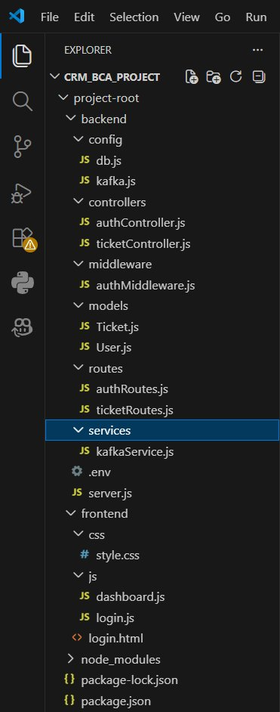
Figure 1: Project Folder Structure — VS Code Explorer
The Explorer panel shows the complete CRM_BCA_project structure. The backend is organised into config (db.js, kafka.js), controllers (authController.js, ticketController.js), middleware (authMiddleware.js), models (User.js, Ticket.js), routes (authRoutes.js, ticketRoutes.js), and services (kafkaService.js). The frontend contains css/style.css, js/login.js, js/dashboard.js, and login.html.

4.2 Installed Dependencies (npm list)
All required Node.js packages were installed and verified using the npm list command. The dependency tree confirms the presence of all core libraries: Express.js for the server, Mongoose for MongoDB ORM, bcryptjs for password hashing, jsonwebtoken for JWT-based authentication, KafkaJS for the Kafka message broker, dotenv for environment variable management, and cors for cross-origin resource sharing.

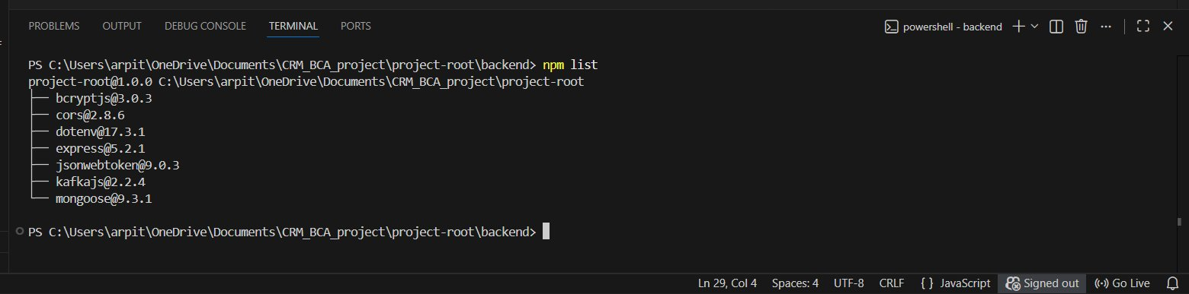
Figure 2: Installed Dependencies — npm list Output
Terminal output of npm list showing all installed packages: bcryptjs@3.0.3, cors@2.8.6, dotenv@17.3.1, express@5.2.1, jsonwebtoken@9.0.3, kafkajs@2.2.4, and mongoose@9.3.1. All dependencies are confirmed as installed and available.

4.3 Backend Server Setup & Execution (US-001)
The main entry point server.js initialises the Express application, connects to MongoDB via db.js, starts the Kafka service via kafkaService.js, registers all API routes (/api/auth and /api/tickets), and starts the HTTP server on port 5000. The terminal confirms the server is running successfully with the message 'Server running on port 5000'.

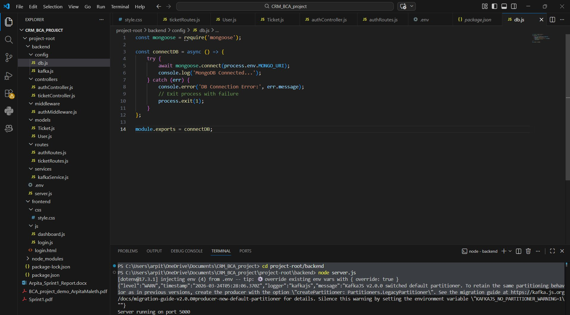
Figure 3: server.js — Express Server Configuration
The file imports dotenv, express, cors, the database connector (config/db.js), and the Kafka initialiser (services/kafkaService.js). It registers /api/auth and /api/tickets routes, sets the port from the .env file (default 5000), and logs a confirmation message on startup. The folder structure in the Explorer confirms all project files are in place.

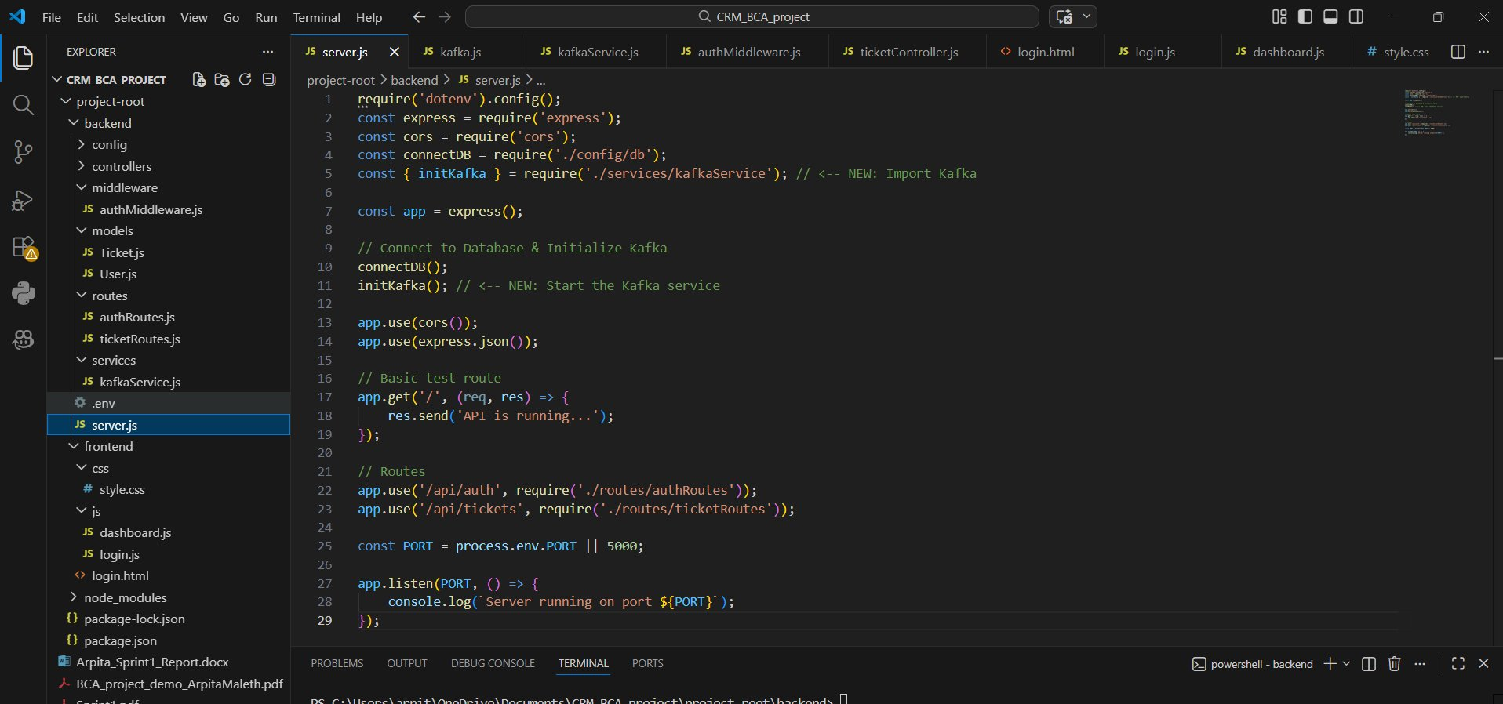
Figure 4: Server Running — Terminal Output (node server.js)
The terminal shows the server being started with node server.js. The KafkaJS v2.0.0 partitioner warning is a non-critical informational message indicating the default partitioner has changed in this version. The final line 'Server running on port 5000' confirms the Express server is live and accepting connections.

4.4 Database Configuration — MongoDB & db.js (US-002)
Database connectivity is handled by config/db.js. The connectDB function uses Mongoose to establish a connection to the MongoDB instance specified in the MONGO_URI environment variable. On success, it logs 'MongoDB Connected...'; on failure, it logs the error and exits the process. This function is called from server.js on startup.

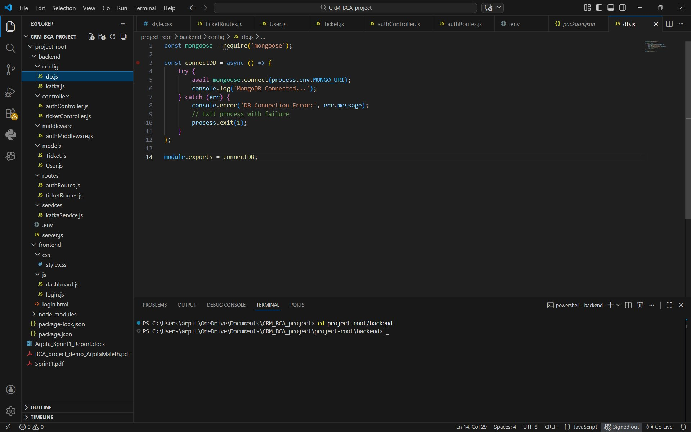
Figure 5: config/db.js — MongoDB Connection Module
The file defines an async connectDB function that calls mongoose.connect() with the MONGO_URI from the .env file. A success log confirms connection, and the catch block handles errors gracefully by calling process.exit(1). The terminal at the bottom shows the backend directory is active and ready.

4.5 Environment Configuration — .env File
All sensitive configuration values are stored in the .env file at the project root. This includes the server port (5000), MongoDB connection string (localhost:27017/crm-db), JWT signing secret, and the Kafka broker address. Using dotenv ensures these values are never hard-coded in source files and remain outside version control.

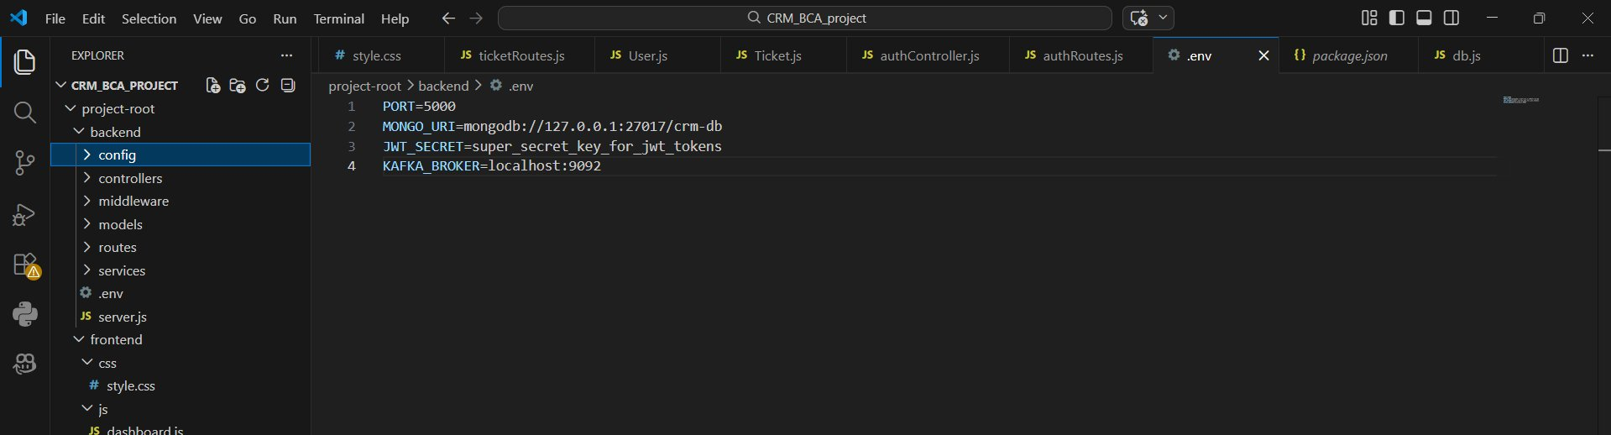
Figure 6: .env — Environment Variables Configuration
The .env file contains four key variables: PORT=5000 (server port), MONGO_URI pointing to the local MongoDB instance at crm-db, JWT_SECRET used for signing and verifying tokens, and KAFKA_BROKER=localhost:9092 which will be used when Kafka integration is activated in Sprint 2.

4.6 User Schema & Password Hashing — models/User.js (US-002 & US-003)
The User model defines the Mongoose schema for all registered users. It includes name, email (unique), password, and role fields. The role field uses an enum constraint, accepting only 'customer' or 'agent', with 'customer' as the default. A Mongoose pre-save hook automatically hashes the password using bcrypt.genSalt(10) and bcrypt.hash() before any user document is persisted — ensuring raw passwords are never stored in the database.

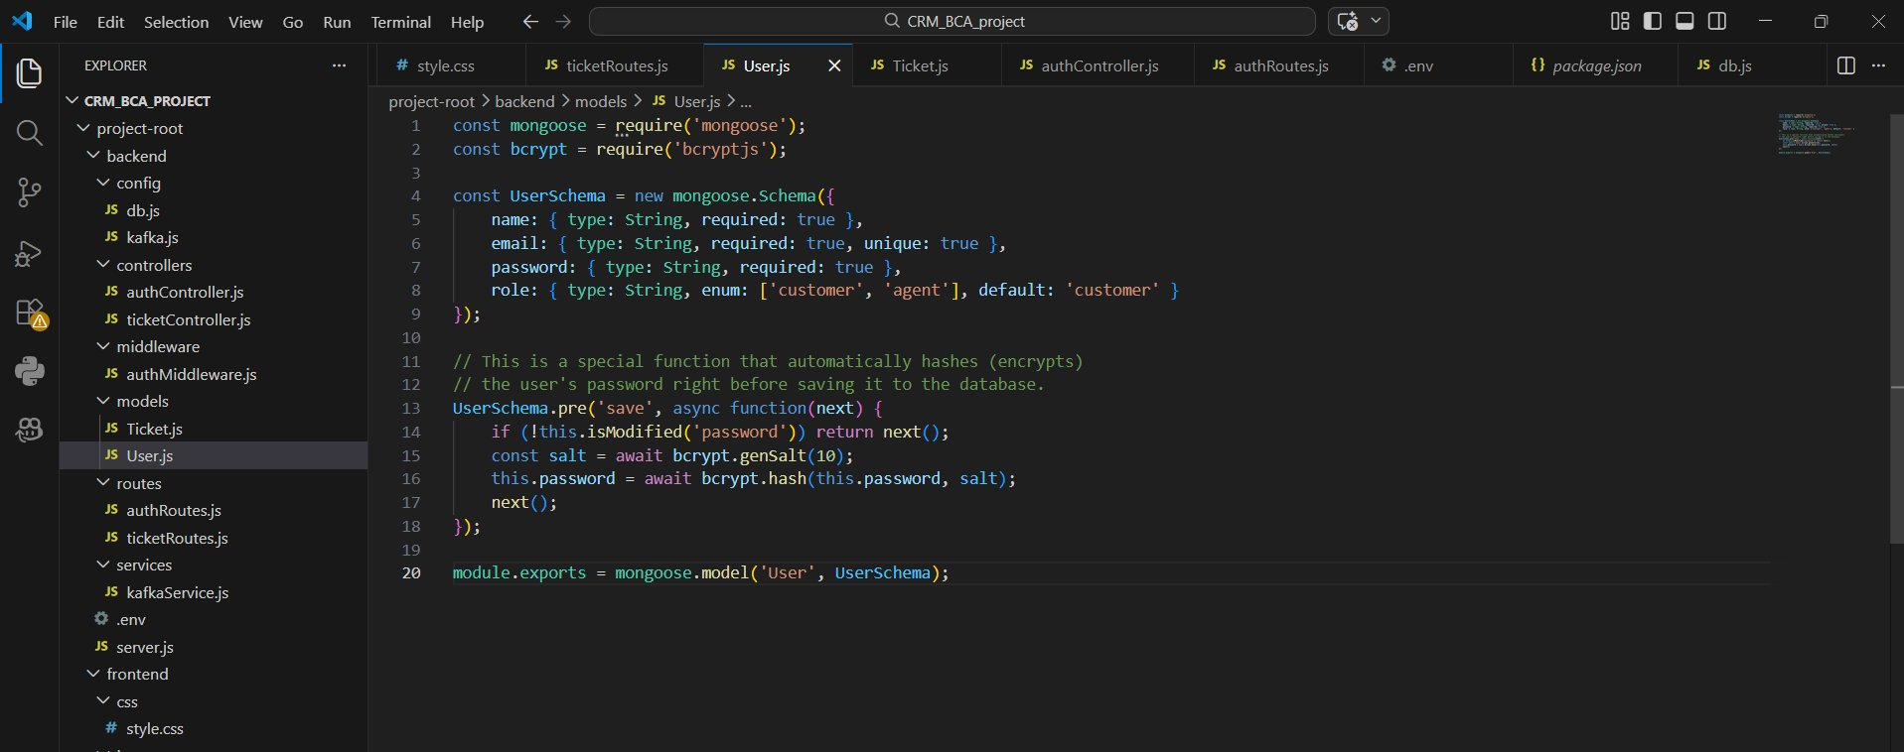
Figure 7: models/User.js — Mongoose Schema with bcrypt Pre-Save Hook
The schema defines four fields: name (String, required), email (String, required, unique), password (String, required), and role (String, enum: ['customer','agent'], default: 'customer'). The pre('save') hook checks if the password has been modified, generates a salt of 10 rounds, hashes the password, and replaces the plain text value before saving. This ensures all passwords in MongoDB are stored as bcrypt hashes.

4.7 Authentication Controller — JWT Token Issuance (US-004)
The login function in authController.js handles credential verification and JWT token generation. After verifying the user's email and comparing the supplied password against the stored bcrypt hash, it constructs a payload containing the user's id and role. It then signs this payload using jwt.sign() with the JWT_SECRET from .env and an expiry of 1 hour. The resulting token and role are returned in the response, and the frontend stores them in localStorage for use on subsequent requests.

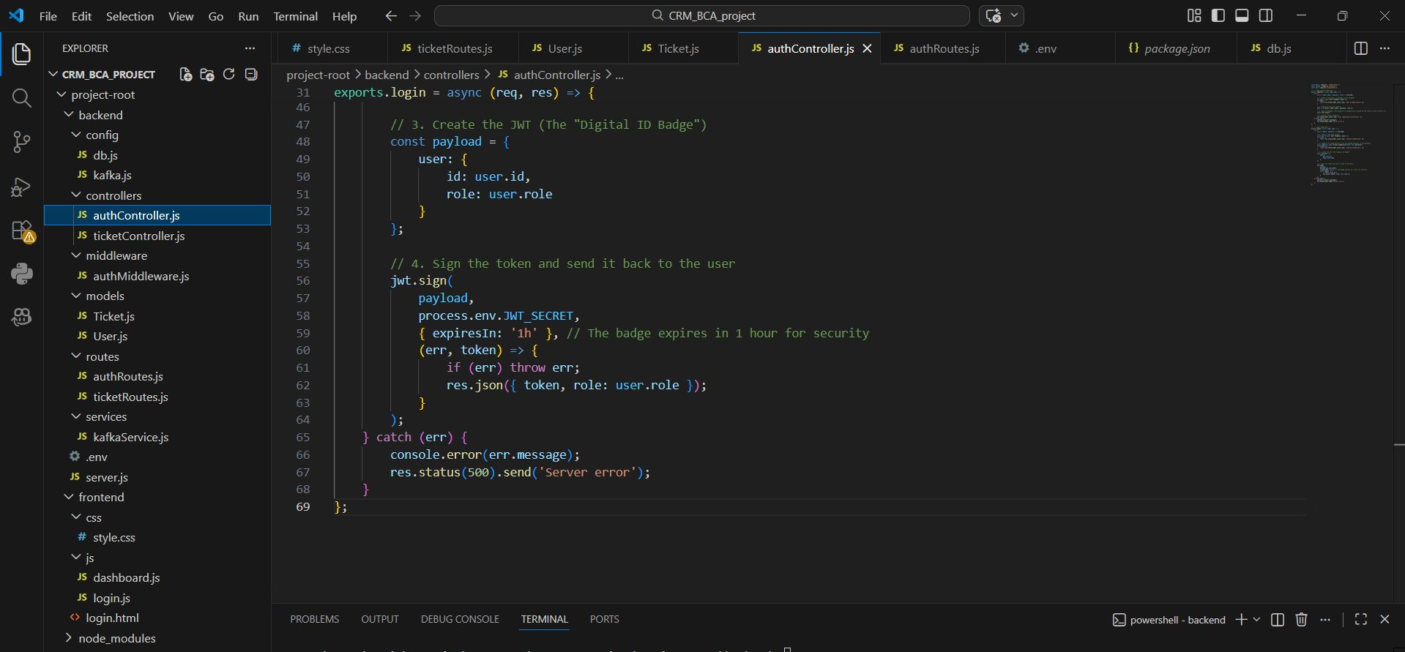
Figure 8: authController.js — JWT Sign & Login Response (Login Function, Lines 46–69)
The code shows the jwt.sign() call with the payload (user id and role), the secret from process.env.JWT_SECRET, and expiry options ({expiresIn: '1h'}). On success, the response sends back { token, role: user.role }, which the frontend uses to set localStorage items and redirect to dashboard.html. The catch block handles server errors with a 500 status.

5. Sprint Execution Detail
Sprint 1 (Wk 1–2) · E1 – Core Infrastructure & Authentication · Planned: 30 pts · Completed: 30 pts · 01 Mar 2026 → 14 Mar 2026
Story ID | Title | Pts | Actual | Completed | Status | Notes / Outcome
US-001 | Node.js & Express Backend Setup | 6 | 6 | 03 Mar 2026 | ✔ Done | Express on port 5000. Auth & ticket routes registered. Kafka service initialised.
US-002 | MongoDB Integration & User Schema | 6 | 6 | 05 Mar 2026 | ✔ Done | Mongoose connected via db.js. User schema with name, email, password, role fields created.
US-003 | Registration Endpoint (bcrypt) | 6 | 6 | 07 Mar 2026 | ✔ Done | POST /api/auth/register live. Password auto-hashed via Mongoose pre-save hook using bcrypt.
US-004 | Login Endpoint (JWT) | 6 | 6 | 10 Mar 2026 | ✔ Done | POST /api/auth/login returns signed JWT with user id and role. authMiddleware.js protects routes.
US-005 | Frontend Login & Registration UI | 6 | 6 | 14 Mar 2026 | ✔ Done | HTML/CSS pages built. Fetch API posts to backend. Token and role saved to localStorage.

Retro Highlights: Backend and database setup completed ahead of schedule. JWT + bcrypt integration worked on first implementation. Frontend Fetch API integration tested successfully with token stored in localStorage.
Impediments: MongoDB connection error on first run (BUG-001, resolved same day). JWT token lost on page refresh (BUG-002, resolved Day 5).

6. Technical Implementation

6.1 Technology Stack
Layer | Technology | Purpose
Backend Runtime | Node.js v18 + Express.js 5 | HTTP server, routing, middleware pipeline
Database | MongoDB + Mongoose 9 | Document store; schema definition and validation
Authentication | JWT (jsonwebtoken 9) + bcrypt 3 | Stateless token auth; password hashing at rest
Message Queue | KafkaJS 2.2 (scaffolded) | Event streaming — producer/consumer configured, not yet live
Environment | dotenv 17 | Secrets management via .env (PORT, MONGO_URI, JWT_SECRET, KAFKA_BROKER)
Frontend | HTML5 + CSS3 + Vanilla JS | Login & registration UI; Fetch API integration
Dev Tools | VS Code + PowerShell + npm | Development environment and package management

6.2 JWT Authentication Flow
When a user submits the login form, the frontend Fetch API sends a POST request to /api/auth/login with the email and password in the JSON body. The backend controller looks up the user by email, compares the supplied password against the stored bcrypt hash, and — on success — creates a JWT payload containing the user's id and role. This payload is signed with the JWT_SECRET and returned to the frontend with a 1-hour expiry. The frontend stores the token in localStorage and redirects the user to the dashboard. All subsequent protected API calls include the token in the Authorization header, which authMiddleware.js validates on every request.

6.3 Password Hashing with bcrypt
Passwords are never stored in plain text. The User.js Mongoose model includes a pre-save hook that intercepts any save operation where the password field has been modified. It generates a salt with 10 rounds using bcrypt.genSalt(10) and then hashes the password with bcrypt.hash(). The resulting hash replaces the plain-text password in the document before it is written to MongoDB. On login, bcrypt.compare() is used to verify the supplied password against the stored hash without ever decrypting it.

6.4 Role-Based Access (Customer & Agent)
The User schema enforces roles using a Mongoose enum constraint: only 'customer' or 'agent' are accepted as valid values, with 'customer' as the default. The role is embedded in the JWT payload at login time, making it available to every protected route via authMiddleware.js without an additional database query. In Sprint 2, this role will be used to enforce access control on ticket routes — customers can only see their own tickets, while agents can see and update all tickets.

6.5 Frontend–Backend API Integration
The frontend login.js file attaches an event listener to the login form's submit event. It reads the email and password fields, sends them as a JSON POST request to http://localhost:5000/api/auth/login using the Fetch API, and awaits the response. On a 200 OK, it extracts the token and role from the response JSON, saves both to localStorage, and redirects the browser to dashboard.html. On failure, it displays the error message returned by the backend via alert().

6.6 Apache Kafka — Current Status
KafkaJS 2.2.4 has been installed and the Kafka broker address (localhost:9092) is configured in the .env file. The kafka.js config file and kafkaService.js service file are scaffolded and imported into server.js. However, the Kafka broker is not running in the local environment during Sprint 1. The KafkaJS warning visible in the terminal (Figure 4) is a non-blocking informational message about the default partitioner change in v2.0.0 — it does not affect the Express server or authentication functionality. Full Kafka producer/consumer integration is planned for Sprint 2.

7. Challenges and Resolutions
Bug ID | Description | Severity | Sprint | Status | Resolution
BUG-001 | MongoDB connection failed on initial local setup | Low | S1 | Fixed | Ensured MongoDB service starts before backend. Added console.log('MongoDB Connected...') in db.js for confirmation.
BUG-002 | JWT token lost on page refresh — user logged out unexpectedly | Medium | S1 | Fixed | Moved token storage from sessionStorage to localStorage. Added token validation check on every page load in login.js.

7.1 MongoDB & Kafka Not Fully Active — Local Environment Note
During Sprint 1, MongoDB is configured and the connection code is in place (db.js), but the MongoDB service requires manual startup on the local Windows machine before the backend is launched. Similarly, Kafka is configured but the Kafka broker is not running locally, which means the initKafka() call in server.js produces a non-critical warning but does not block the server. Both services are expected to be running consistently in Sprint 2 once the development environment is stabilised. This is clearly noted in the codebase and does not affect the authentication functionality delivered in Sprint 1.

8. Outcome
• Express.js backend server is fully operational on port 5000 with auth and ticket routes registered.
• MongoDB User schema with role-based fields (customer / agent) is implemented and validated.
• User registration endpoint is live — passwords are automatically hashed via bcrypt pre-save hook.
• User login endpoint is live — valid credentials return a signed JWT token with a 1-hour expiry.
• authMiddleware.js is implemented to protect routes using JWT verification.
• Frontend login and registration pages are built and connected to backend APIs via Fetch.
• Token and role are stored in localStorage, enabling persistent sessions across page loads.
• KafkaJS and Kafka configuration are scaffolded and ready for Sprint 2 activation.
• All 5 user stories (30 story points) delivered. Zero carry-overs. 2 bugs resolved within sprint.

9. Conclusion
Sprint 1 successfully established the complete foundational architecture of the Real-Time Customer Support Ticket CRM system. All planned user stories were delivered on time with no carry-overs, and both bugs identified during development were resolved within the sprint. The authentication system — built on bcrypt password hashing and JWT token-based sessions — provides a secure, stateless foundation that can be extended across all future sprints without architectural changes.

The MVC-style project structure, clean separation of concerns, and .env-based configuration management ensure the codebase is maintainable and ready to scale. With the backend, database, and frontend integration fully in place, Sprint 2 will focus on implementing the core ticket management system and activating the Apache Kafka real-time event pipeline — the key differentiator of this project.

Developer: Arpita Maleth | CU23BCA0011A | Chanakya University
Faculty Supervisor: _______________________________
Report Date: March 2026

This document serves as the official Sprint 1 Execution Completion Report for the Real-Time Customer Support Ticket CRM project.

